Year 23 Moderate Level

Question 1:
Select the combination of numbers from the options in which the given letters are arranged accordingly to form a meaningful English word.

D G I E U
1 2 3 4 5

(A) 4, 3, 2, 1, 5 (B) 2, 5, 3, 1, 4 (C) 3, 5, 1, 2, 4 (D) 2, 3, 1, 5, 4

Question 2:
Observe the given figures carefully and select the CORRECT option.

- The shaded fraction of figure P is 11/20.
- The unshaded fraction of figure Q is 3/8.
- If one more rectangle will be shaded in figure P, then the unshaded fraction of figure P will be 7/20.
- All of these.

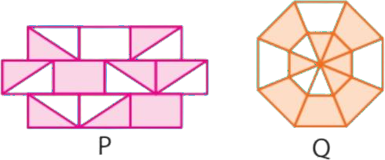

Question 3:
Study the given number bond carefully. Find the value of P + Q.
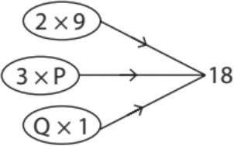

(A) 30 (B) 18 (C) 28 (D) 24

Question 4:
The codes of some digits are given below.

DIGITS | 5 | 3 | 6 | 1 | 7 | 8 | 4 | 2
CODES | @ | # | U | $ | H | E | % | ©

Find the code for 85261.

(A) E@#$ (B) %@©UH (C) E@©U$ (D) H@©#%

Question 5:
Which of these has the same value as 892 - 48?
(A) 892 - 8 + 40 (B) 892 - 40 + 8
(C) 892 - 50 - 2 (D) 892 - 50 + 2

Question 6:
Look at the cinema timetable.

 | Start Time | End Time
Fluffy Puppies | 11:30 | 14:30
Alien Invasion 3 | 15:10 | 17:10
High School Heartache | 17:30 | 19:45
Super Spooky Film | 20:00 | 22:45
Which film is the shortest?

A. Fluffy Puppies.
B. Alien Invasion 3.
C. High School Heartache.
D. Super Spooky Fil

Question 7:
Choose the direction you will be facing if you face east and turn 2 right angles clockwise.
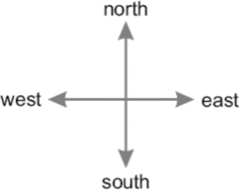

A. north
B. east
C. south
D. west east

Question 8:
How many 25cm × 25cm squares fit in a 50cm * 1m rectangle?
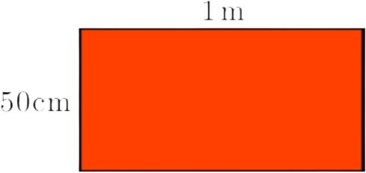

A. 1
B. 2
C. 4
D. 6
E. 8

Question 9:
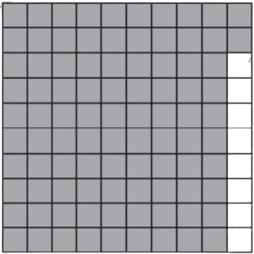
Use the picture below to answer the question.

Which decimal number names the shaded part of this square?

A. 0.08
B. 0.20
C. 0.92
D. 0.98

Question 10:
Use the number line below to answer the question.
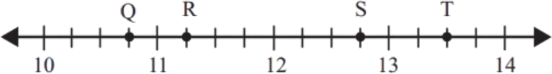

Which point is located at 12 ¾?

A. point Q
B. point R
C. point S
D. point T

Question 11:

Lotus birds step or jump from lily pad. They will not step into water.

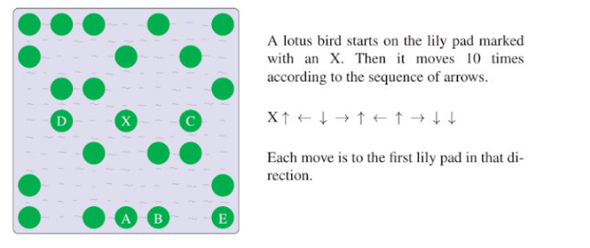
After these 10 moves, on which lily pad does the lotus bird finish?

A. A
B. B
C. C
D. D
E. E

Question 12:
Reh attends swimming classes from 4:00 p.m. for 1 hour. He then takes 15 minutes to reach for his guitar classes. He learns guitar for 50 minutes and then takes 20 minutes to reach his home.
At what time does he reach home?

A. 5:55 p.m.
B. 6:25 a.m.
C. 6:25 p.m.
D. 6:10 a.m.

Question 13:
Solve:
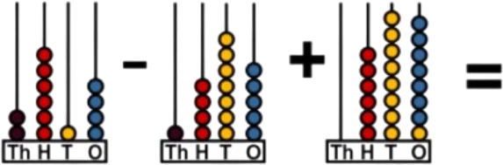

- 1,401
- 1,936
- 1,826
- 2,435

Question 14:
A gray circle with 2 large holes in it is put on top of a clock-face, as shown.
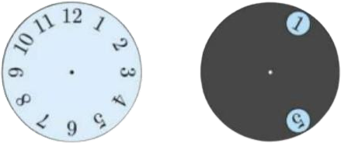

The gray circle is turned around its center. Which 2 numbers is it possible to see at the same time?

- 4 and 9
- 6 and 9
- 5 and 9
- 7 and 12
- 5 and 10

Question 15:
There are 7 houses north of Road A, 8 houses east of Road B and 5 houses south of Road
A. How many houses are west of Road B?
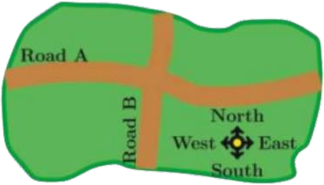

A. 4
B. 5
C. 6
D. 7
E. 8

Question 16:
Jess arranges three or four of these cards to make a number.
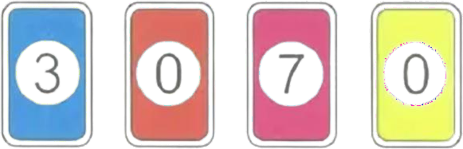

How many numbers can Jess make that are multiples of 100?

A. 2
B. 4
C. 6
D. 8

Question 17:
Ben collected 68 cans.
Jack collected 109 cans.
How many cans did Ben and Jack collect altogether?

A. 167
B. 168
C. 176
D. 177

Question 18:
This bucket holds 10 litres when filled to the top.
The dotted line shows how much water is in the bucket.
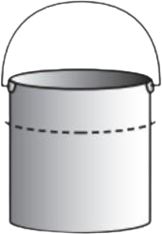

About how much water is in the bucket?

- 3 litres
- 5 litres
- 7 litres
- 9 litres

Question 19:
The base of this solid has 4 equal sides.
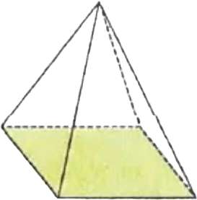
What shape is the base?

- a square.
- a circle.
- a triangle.
- a pyramid.

Question 20:
The graph below shows the number of students with each eye colour in Mrs Smith’s class.
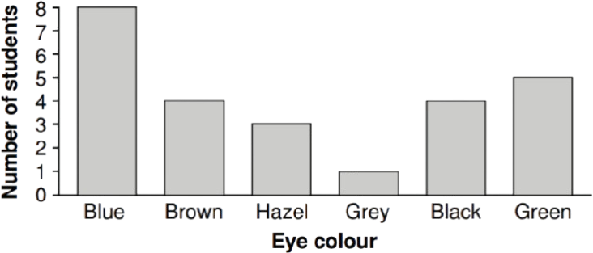

Which statement is true?

  - More students have brown eyes than black eyes.
  - Less students have hazel eyes than grey eyes.
  - Green is the most common eye colour.
  - Blue is the most common eye colour.

Question 21:
How many 3s are there in 21?
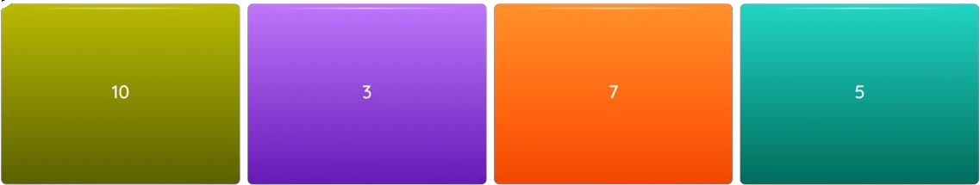

- 10
- 3
- 7
- 5

Question 22:
Karen spins the arrow on this spinner once.
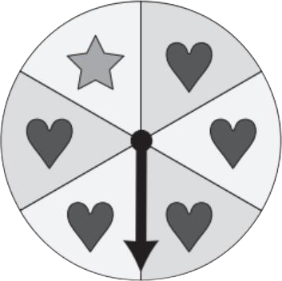

What is the chance of the arrow landing on a?

- certain
- likely
- unlikely
- impossible

Question 23:
What is the next number?
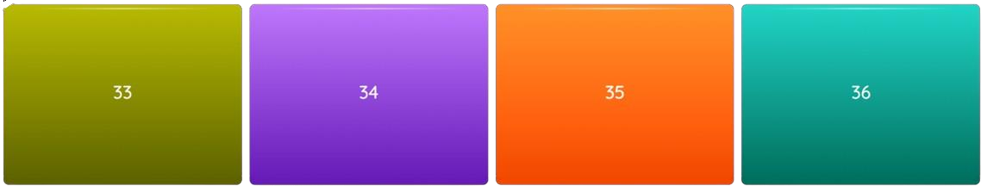
17, 21, 25, 29,

Question 24:
This pizza's been cut into 8 pieces. 2 slices are how much of the pizza in fractions?

- 1/5.
- 1/4.
- 1/3.
- 1/2.

Question 25:
Every box shows the result of the number on the left and on the top. Which number is written behind the heart?
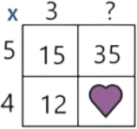

- 25.
- 27.
- 28.
- 29.
- 30.

Year 23 Hard Level Keys

